**Session – 1 (Introduction to working with R)**

**Assignment – 2**

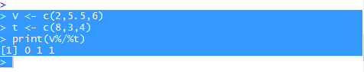

1. Not Discussed in the session.
2. Read Csv into R

MyData <- read.csv()